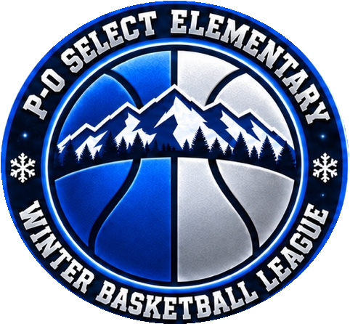

P O Select League
Student Athlete Code of Conduct
Student-athletes recognize that participation in the P-O Select League is a privilege that requires responsible behavior throughout the season. The following rules clarify these expectations and provide direction to student-athletes.
1. Citizenship. All student-athletes must demonstrate good citizenship in school and the community. Behavior that reflects unfavorably on the team, coaches, or P-O Select League, or results in a criminal penalty or indictment, may warrant suspension or dismissal. This includes, but is not limited to, cheating, defiance, lying, disrespect toward people or property, and possession of unauthorized or stolen property.
2. Academic Eligibility. All student-athletes must meet the academic eligibility requirements established by their parents or guardians.
3. Attendance and Communication. All student-athletes must attend scheduled practices, games, and tournaments unless necessary absences have been communicated to the coach. The league recognizes that student-athletes may participate in multiple sports during a season. A high school sport that is in season takes precedence; however, absences must still be communicated to the coach.
4. Substances Language and Sportsmanship. All student-athletes must refrain from using alcohol, tobacco, or other unauthorized substances. Poor sportsmanship and vulgar language are prohibited at practices, games, and tournaments.
5. Tournament Curfew. All student-athletes must observe an 11:00 p.m. curfew at tournaments and get proper rest for basketball participation. After curfew, boys and girls must remain in their assigned rooms unless they are members of the same family.
6. Jewelry. Student-athletes may not wear jewelry during any game.
7. Equipment and Gear. Student-athletes are responsible for their equipment and gear and are expected to return league-issued items or replace equipment and gear that is lost or damaged.
8. Respect Loyalty and Self Control. All student-athletes are expected to demonstrate respect for teammates, coaches, game officials, and opponents; demonstrate loyalty to the team and coaches; and control their emotions and conduct themselves appropriately as representatives of the P-O Select League.
I agree to follow all P-O Select League rules and understand that I may be suspended or removed from the team or league for violating any of the rules above.
______________________________________________ ____________________
Student-Athlete Signature Date
_____________________________________________________________________
Student-Athlete Printed First and Last Name

